**Activity 2: System Integration Planning**

**Group Name: JCTAK**

**Team Member: Diel, John Christian S.**

**Pido, Kevin**

**Queing, Angelica**

**Tanihata Sacala, Tiara**

**Section: BSIT302 Date: October 8, 2024**

1. **General Problem**

Beginners Problem in Entering Python Language

1. **Specific Problem**
2. Overwhelming amount of Resources
3. Lack of Structured Learning Paths
4. Difficulty in Applying Theories into Practice
5. Poor Feedback Accuracy and Error Handling
6. Fear of Errors
7. **Specific Solution**
8. We will compile the lessons and make it easy to read and absorb.
9. We will provide a structured path for them to follow.
10. We will hand out small projects where theories can be applied.
11. We will provide easy to understand error explanations, and put up a reference guide for common mistakes.
12. We will put small motivational quotes within lessons and show that people make mistakes and they can learn from it.
13. **System Work flow**

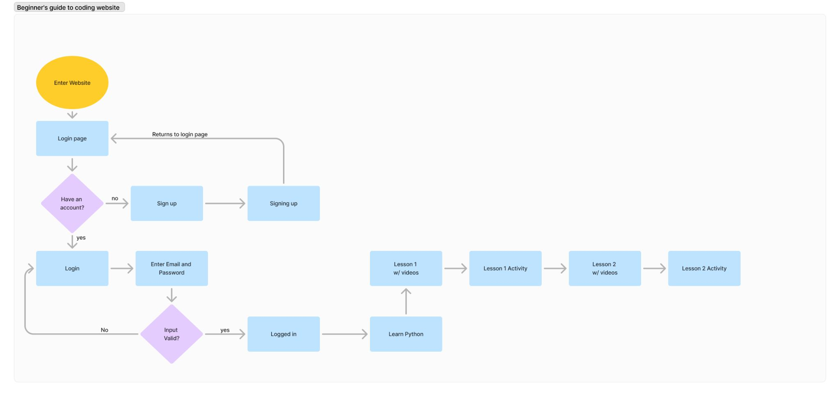

1. **System Desciption**

The Python Learning for Beginners will provide a starting point for anyone who’s new to programming. The website will be a guide to new programmers on how to start programming on python

**System Components:**

1. **User Interface**

* **Learner Dashboard:** Displays progress, activities, and lessons
* **Profession Dashboard:** Facilitates professor moderation of student submissions, and allows professors to manage student submissions. This also allows the Professors to track student performance, progression and participation

1. **Course Content Management System:**

* **Professor Upload Content:** An interface where professors can upload their lessons, activities, assignments, quizzes, projects, etc. in different forms of formats
* **Content scheduling:** Professors can schedule their lessons when it released progressively as students

1. **Learning Paths and Learning Points System**

* **Professor Learning Paths:** Professors can display the learning path they want to use
* **Learning Point System:** Students can rate whether the course they have taken is useful, is effective and whether the professor did good at teaching their course.

1. **Progress Tracking and Reporting**

* **Detailed Progress Reports**: Learners can track their completed Lessons and Activities.

1. **Notification and Reminders:**

* **Email Alerts:** There will automated alerts for assignment deadlines, new lessons and rescheduled activities.
* **Custom Notifications:** Students may customize the notification they receive, to make sure that they do not get overwhelmed while updated.

1. **User Interface Representation**

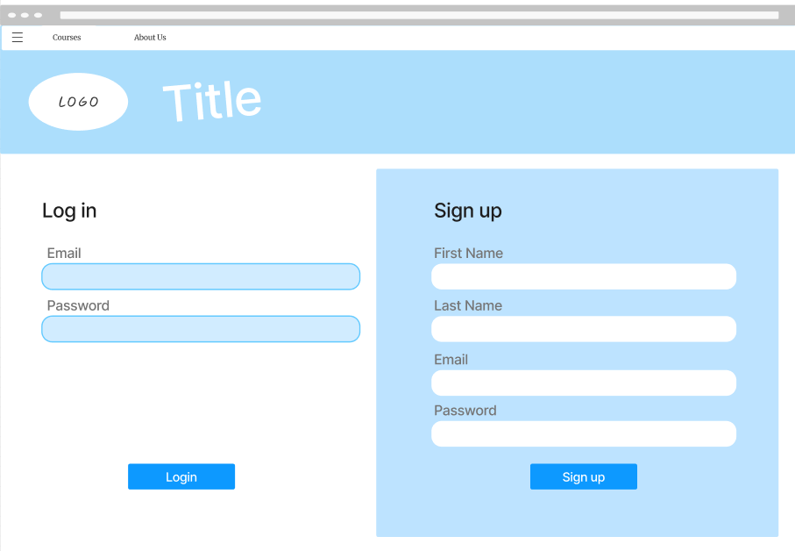

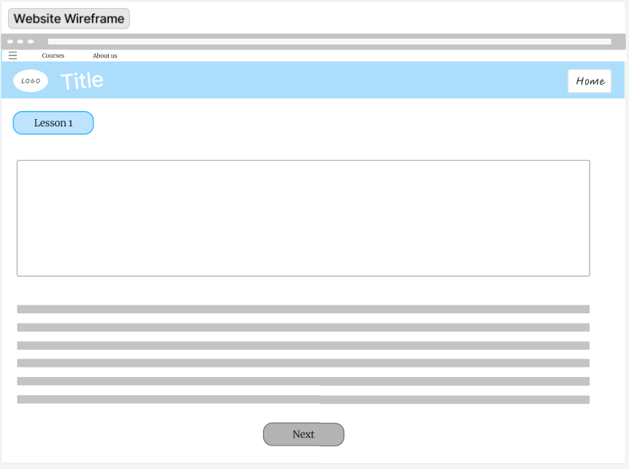

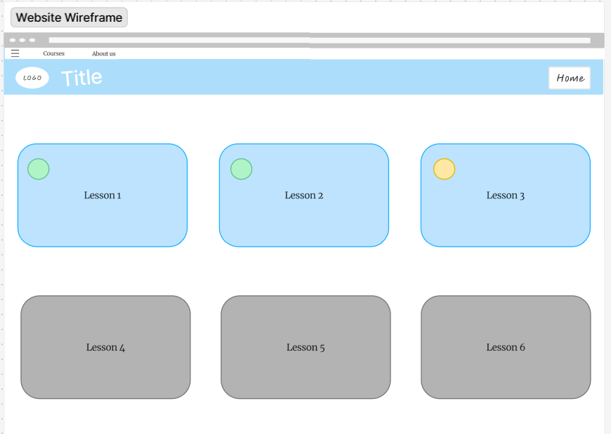

**(provide description)**